

MILITARY TECHNICAL ACADEMY

FACULTY OF INFORMATION TECHNOLOGY

**BOOKSTORE MANAGEMENT**

**SOFTWARE REQUIREMENTS SPECIFICATION**

**Ha Noi, 11/2017**

**CATALOG**

1. Introduce 5

1.1. Purpose of the document 5

1.2. Document scope 5

1.3. Definitions. 5

1.4. References 5

1.5. Document description 6

2. Overview of software 7

2.1. General requirement of software 7

2.2. Purpose of software 7

2.3. User 7

2.4. The overall model of the software 8

3. Analysis business process 9

*3.1. Use case “update goods”* 9

3.2. Use case “Update information of staff” 10

*3.3. Use case “Update information of customer”* 12

3.4. Use case “Goods import management” 13

3.5. Use case “Sales Manager” 14

3.6. Use case “Create receipt note” 15

3.7. Use case “Create bill” 16

4. Specific requirements for functional software 18

4.1 Specifies “the login” function 18

4.2. Specifies “View information of goods” 18

4.3. Specifies “Add goods” function. 19

4.4. Specifies “Update information of goods” function 19

4.5. Specifies “Delete goods” function 20

4.6. Specifies “View staff information” function 20

4.7. Specifies “Add staff” function 21

4.8.Specifies “Edit staff information” function 21

4.9.Specifes “Delete staff information” function 22

4.10.Specifies “View customer information” function 23

4.11.Specifies “Add customer” function 23

4.12.Specifies “ Edit customer information” function 24

4.13.Specifies “Delete cuatomer information” function 24

4.14Specifies “View import information” function 25

4.15.Specifies “ View detail of receipt note” function 25

4.16.Specifies “Add receipt note” function 26

4.17.Specifies “View sales information” function 26

4.18. Specifies “View detail of bill” function 27

4.19. Specifies “Add bill” function 28

4.20. Specifies “Search for goods” function 28

4.21. Specifies “Search for staff” function 29

4.22. Specifies “Search for customer” function 29

4.23. Specifies “Print receipt note” function 30

4.24. Specifies “Print bill” function 31

4.25. Specifies “Create user account” function 31

4.26. Specifies “Delete user information” function 32

5. Other requirements 33

5.1. Ease of Use Requirements 33

5.2. Stability requirements 33

5.3. Security requirements 33

5.4. Backup and restore requirements 34

5.5. Support eligibility requirements 34

5.6. Technology requirements 34

5.7. Communication requirements 35

5.8. Requires user documentation and online support 35

5.9. Legal requirements 35

5.10. Requirements for applicable standards 36

# 1. Introduce

### 1.1. Purpose of the document

This document was developed for the purpose of analyzing, specifying the requirements for the bookstore management software development project. This document describes software requirements for the entire system or for each of the subsystems used as input to the design process, the programming usecase construction, the system test of the system build.

### 1.2. Document scope

Documentation is the result of a survey of the requirements, learning the documents related to the necessary functions of the bookstore management system.

### 1.3. Definitions.

| **Configuration** | **Definition** | **Explaining** |
| --- | --- | --- |
| BSM | Bookstore Management | Name of project. |
| DB | Database | Where to store information and allow access. |

### 1.4. References

The references are:

- Document about action of bookstore.

- Projects related to management in the Internet.

### 1.5. Document description

The structure of the specification document includes the following sections:

* **Part 1** **- Introduce**: General introduction of the document, help the reader visualize the content, purpose and general layout of the document.
* **Part 2 - Overview of software**: Identify common requirements, objectives, user objects, and build the overall model of the software
* **Part 3 - Usecase process analysis**: Presentation and analysis of usecase processes of the bookstore management system module.
* **Part 4 - Functional requirements of the software:** Demonstrates the functional requirements that the software should provide.
* **Part 5 - Other requirements**: Presentation of non-functional requirements: ease of use, stability, performance, security, backup and restore capabilities, supportability, and more.
* **Part 6 - Software acceptance standards**: Present the acceptance criteria for the software if it satisfies the requirements

# 2. Overview of software

### 2.1. General requirement of software

General requirements of bookstore management software:

- Administer the user by admin: admin will assign the user group by "import", "sales". User can change password to access the system.

- Process the updating of goods information, employee information, customer information.

- Handling of goods import and receipt.

- Handle sales process and bill sales.

### 2.2. Purpose of software

The bookstore management process is more convenient, faster and more accurate.

### 2.3. User

There are two user group :

* Management group: control all of the whole system.
* Major group :
* Import staff.
* Salesman.

### 

### 2.4. The overall model of the software

### 

# 3. Analysis business process

Describe in detail each specific profession, allowing members to build on the best quality software. With the UseCase (UC) model, software requirements are described by UCs and in additional specifications.

**Use case diagram**

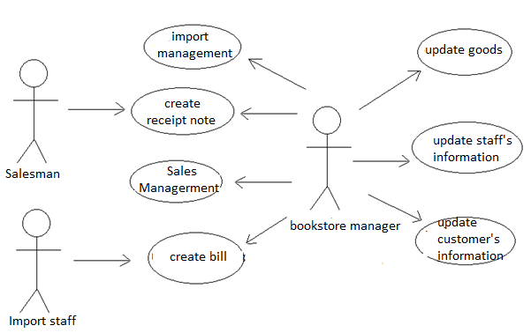

3.1. Use case “Update goods”

#### 3.1.1. Event triggered

When entering the goods or changing the information of goods, information of the goods must be updated.

#### 3.1.2. Business process model

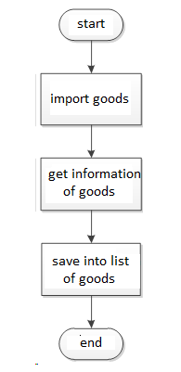

#### 3.1.3. Describe the steps

* Step 1 : Get information of goods
* Input: Import note
* Out put: Good’s information entered
* Step 2 : Update to inventory file
* Input : Information of goods need to store
* Đầu ra: File stores information of goods

### 3.2. Use case “Update information of staff”

#### 3.2.1. Event triggered

Any employee changes (addition, modification, deletion) will update the employee’s information.

#### 3.2.2. Business process model

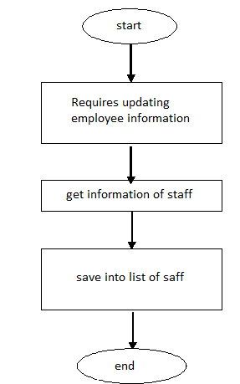

#### 3.2.3. Describe the steps

* Step 1 : Get information of staff
* Input: Requires updating employee information.
* Output: information of staff
* Step 2 : Update to employee’s information file
* Input : information of staff
* Output: The file stores employee information.

### 3.3. Use case “Update information of customer”

#### 3.3.1. Event triggered

Whenever there is a change in the employee's information (addition, correction, abandonment), the employee management department will have to update the customer information file.

#### 3.3.2. Business process model

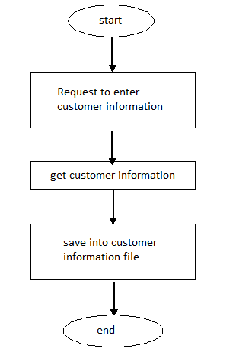

#### 3.3.3 Describe the steps

* Step 1 : Get information of customer
* Input: request to update customer information.
* Output: information of customer
* Step 2 : Update to the file store customer information
* Input : information of customer
* Output: The file stores customer information.

### 3.4. Use case “Goods import management”

#### 3.4.1. Event triggered

When there is a change in the goods import information (add, edit, remove), bookstore management will have to update the import file.

#### 3.4.2. Business process model

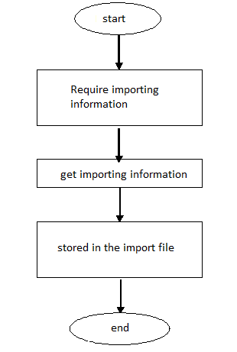

#### 3.4.3. Describe the steps

* Step 1 : Get importing information
* Input: Request to update importing information.
* Output: importing information
* Step 2 : Update to the import information file
* Input : importing information.
* Output: The file stores the importing information

### 3.5. Use case “Sales Manager”

#### 3.5.1. Event triggered

When there is a change of sales information (supplement, edit, remove), bookstore management will have to update the sales information file.

*3.5.2. Business process model*

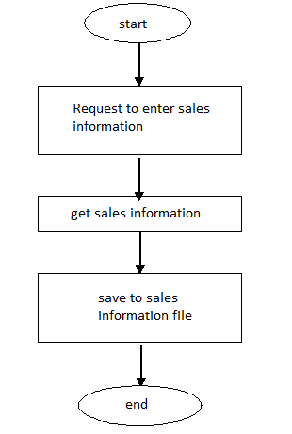

#### 3.5.3. Describe the steps

* Step 1 : Get sales information.
* Input: Request updated sales information
* Output: sales information.
* Step 2 : Update to sales information file
* Input : sales information
* Output: salses information file

### 3.6. Use case “Create receipt note”

#### 3.6.1. Event triggered

When the goods are imported, the import staff create a receipt note.

#### 3.6.2. Business process model

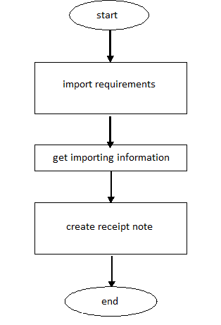

#### 3.6.3. Describe the steps

* Step 1 : get importing information
* Input: request update importing information.
* Output: goods import information.
* Step 2 : Create receipt note
* Input: goods import information.
* Output: receipt note.

### 3.7. Use case “Create bill”

#### 3.7.1. Event triggered

When have ordering, the salesman create bill.

#### 3.7.2. Business process model

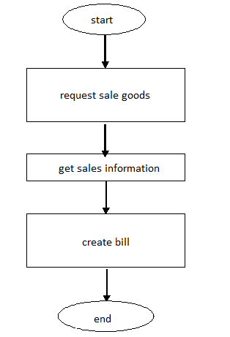

#### 3.7.3. Describe the steps

- Step 1 : Get information on the goods sold and customer information

* Input: request sale goods.
* Output: information on the goods sold and customer information.
* Step 2 : Create bill
* Input : information on the goods sold and customer information.
* Output: bill.

# 4. Specific requirements for functional software

## To perform the above mentioned operations, the software must have the following functions:

### 4.1 Specifies “the login” function

|  |  |
| --- | --- |
| **Use case:** {UC_01_ User login system} | |
| Purpose | The user logs in to perform their tasks. |
| Describe | Allows the user to log in to use the supported functions for this user object. |
| Actor | User |
| Pre-conditions | Access to bookstore management software. |
| Basic flows | * Enter account name * Enter your account password |
| Alternative Flows | * Login failed because of wrong account name * Login failed because password does not match account |
| The following conditions | Log in successfully and start using other system functions. |

### 4.2. Specifies “View information of goods”

|  |  |
| --- | --- |
| **Use case:** {UC_02_View information of goods} | |
| Purpose | View information stored |
| Describe | Show detail information of goods |
| Actor | Bookstore management |
| Pre-conditions | * Successfully logged in with bookstore management access * Click on the goods to see |
| Basic flows | Show all merchandise in the bookstore |
| Alternative Flows | View detail of a goods |
| The following conditions | Know the goods in the bookstore |

### 4.3. *Specifies “Add goods” function.*

|  |  |
| --- | --- |
| **Use case:** {UC_04_Add goods} | |
| Purpose | Add merchandise sold in bookstores |
| Describe | Add goods not in the bookstore or add information to the goods |
| Actor | The bookstore manager |
| Pre-conditions | * Successfully logged in with bookstore management access * Merchandise, commodity code is required * Add cargo information * Activate more button on commodity form |
| Basic flows | Add a goods |
| Alternative Flows | Commodity information is missing |
| The following conditions | Goods have been added |

### 4.4. Specifies “Edit information of goods” function

|  |  |
| --- | --- |
| **Use case:** {UC_03_Edit information of goods } | |
| Purpose | Update information of goods |
| Describe | Change the previously entered information of the goods |
| Actor | The bookstore manager |
| Pre-conditions | * Successfully logged in with bookstore management access * Click on the item and select the item you want to repair * Goods need to change the information being displayed * Activate the Edit button on the commodity form |
| Basic flows | Change all the information of a commodity except the commodity code |
| Alternative Flows | After correcting some incomplete information: name of goods, quantity, price, .. |
| The following conditions | Commodity information is stored in the database with the information has been changed correctly |

### 4.5. Specifies “Delete goods” function

|  |  |
| --- | --- |
| **Use case:** {UC_04_Delete goods} | |
| Purpose | Remove the merchandise sold in the bookstore |
| Describe | Delete the previously entered information of the goods |
| Actor | The bookstore manager |
| Pre-conditions | * Successfully logged in with bookstore management access * Click the item and select the goods to delete * The goods to be deleted are being displayed * Activate the Delete button on the commodity form |
| Basic flows | Delete all information of a staff |
| Alternative Flows | After deleting merchandise is no longer stored. |
| The following conditions | Goods cleared |

### 4.6. Specifies “View staff information” function

|  |  |
| --- | --- |
| **Use case:** {UC_02_View staff information} | |
| Purpose | View employee information stored |
| Describe | Display detail of staff information |
| Actor | The bookstore manager |
| Pre-conditions | * Successfully logged in with bookstore management access * Click to select employee |
| Basic flows | View all staffs |
| Alternative Flows | View detail of staff |
| The following conditions | Know the staff working for the bookstore |

### 4.7. Specifies “Add staff” function

|  |  |
| --- | --- |
| **Use case:** {UC_04_Add staff} | |
| Purpose | Add staff |
| Describe | Add staff or add information to employees |
| Actor | The bookstore manager |
| Pre-conditions | * Successfully logged in with bookstore management access * Enter employee, must have employee code * Add employee information * Activate additional button on employee management form |
| Basic flows | Add a staff |
| Alternative Flows | Staff information is missing |
| The following conditions | Staff has been added |

### 4.8.Specifies “Edit staff information” function

|  |  |
| --- | --- |
| **Use case:** {UC_03_Edit staff information } | |
| Purpose | Edit staff information |
| Describe | Change the employee's previously entered information |
| Actor | The bookstore manager |
| Pre-conditions | * Successfully logged in with bookstore management access * Click on employee management and select employee to edit * Employees need to change the information being displayed * Activate the Edit button on the employee management form |
| Basic flows | Change all information of an employee except commodity code |
| Alternative Flows | After some correction, the input is not complete. |
| The following conditions | Staff information is stored in the database with the information has been changed correctly |

## 

### 4.9.Specifes “Delete staff information” function

|  |  |
| --- | --- |
| **Use case:** {UC_04_Delete staff information } | |
| Purpose | Delete staff information |
| Describe | Deletes the employee's previously entered information |
| Actor | The bookstore manager |
| Pre-conditions | * Successfully logged in with bookstore management access * Click on employee management and select employee to delete * Display employee needs to be removed * Activate the Delete button on the employee management form |
| Basic flows | Delete staff information |
| Alternative Flows | After the deletion of employees no longer be stored. |
| The following conditions | Employee has been deleted the whole row |

### 4.10.Specifies “View customer information” function

|  |  |
| --- | --- |
| **Use case:** {UC_02_View customer information} | |
| Purpose | View stored customer information |
| Describe | Display detail customer information |
| Actor | The bookstore manager |
| Pre-conditions | * Successfully logged in with bookstore management access * Click to select customers to view detail |
| Basic flows | Display all customers |
| Alternative Flows | View detail information of customer |
| The following conditions | Know customer information |

### 4.11.Specifies “Add customer” function

|  |  |
| --- | --- |
| **Use case:** {UC_04_Add customer} | |
| Purpose | Add a customer |
| Describe | Add customers or add information to customers |
| Actor | The bookstore manager |
| Pre-conditions | * Successfully logged in with bookstore management access * Enter customer, customer code is required * Add customer information * Activate additional button on customer form |
| Basic flows | Add a customer |
| Alternative Flows | Customer information is missing |
| The following conditions | Customer has been added |

### 4.12.Specifies “ Edit customer information” function

|  |  |
| --- | --- |
| **Use case:** {UC_03_Edit customer information} | |
| Purpose | Edit customer information |
| Describe | Change the previously entered information of the customer |
| Actor | The bookstore manager |
| Pre-conditions | * Successfully logged in with bookstore management access * Click on customer management and select customer to edit * Customers need to change the information being displayed * Activate the Edit button on the customer management form |
| Basic flows | Change all of a customer's information except the code |
| Alternative Flows | After some correction, the input is not complete. |
| The following conditions | Customer information is stored in the database with the information has been changed correctly |

### 4.13.Specifies “Delete cuatomer information” function

|  |  |
| --- | --- |
| **Use case:** {UC_04_Delete customer information} | |
| Purpose | Delete customer information |
| Describe | Deletes the previously entered information of the customer |
| Actor | The bookstore manager |
| Pre-conditions | * Successfully logged in with bookstore management access * Click on customer management and select customer to delete * Customer need to delete is being displayed * Activate the Delete button on the customer management form |
| Basic flows | Delete all information a customer |
| Alternative Flows | After deleting the customer is no longer stored. |
| The following conditions | Customer has been deleted. |

### 4.14Specifies “View import information” function

|  |  |
| --- | --- |
| **Use case:** {UC_02_View import information } | |
| Purpose | View import information |
| Describe | Show details of imports |
| Actor | The bookstore manager |
| Pre-conditions | * Successfully logged in with bookstore management access * Click to enter |
| Basic flows | Shows all imports |
| Alternative Flow | View detail of a receipt note |
| The following conditions | Know importing |

### 

### 4.15.Specifies “ View detail of receipt note” function

|  |  |
| --- | --- |
| **Use case:** {UC_02_View detail of receipt note } | |
| Purpose | View the information of a receipt note |
| Describe | Displays the goods entered in the import |
| Actor | The bookstore manager |
| Pre-conditions | * Successfully logged in with bookstore management access * - Click on the receipt note to view |
| Basic flows | Display all the goods in the receipt note |
| Alternative Flows |  |
| The following conditions | Know detail of a receipt note |

### 4.16.Specifies “Add receipt note” function

|  |  |
| --- | --- |
| **Use case:** {UC_04_Add receipt note} | |
| Purpose | Add a receipt note |
| Describe | Add information of receipt note |
| Actor | The bookstore manager và import staff |
| Pre-conditions | * Successfully logged in with bookstore management and import staff access * Add a receipt note, code is required * Activate more buttons on the form |
| Basic flows | Add a receipt note |
| Alternative Flows | A receipt note is missing information |
| The following conditions | A receipt note has been added |

## 

### 4.17.Specifies “View sales information” function

|  |  |
| --- | --- |
| **Use case:** {UC_02_View sales information } | |
| Purpose | View sales information |
| Describe | Show detailed sales information |
| Actor | The bookstore manager |
| Pre-conditions | * Successfully logged in with bookstore management access * Click to view a bill |
| Basic flows | Show all bookstore sales |
| Alternative Flows | View detail of bill |
| The following conditions | Know the sales information |

### 4.18. Specifies “View detail of bill” function

|  |  |
| --- | --- |
| **Use case:** {UC_02_View detail of bill } | |
| Purpose | View deatail of bill information |
| Describe | Displays the goods entered in the sale |
| Actor | The bookstore manager |
| Pre-conditions | * Successfully logged in with bookstore management access * -Click on the invoice to view |
| Basic flows | Display all the goods and customer information in the invoice. |
| Alternative Flows |  |
| The following conditions | Get a detail of the bill |

### 

### 4.19. Specifies “Add bill” function

|  |  |
| --- | --- |
| **Use case:** {UC_04_Add bill} | |
| Purpose | Add bill |
| Describe | Bill information |
| Actor | The bookstore manager và salesman |
| Pre-conditions | * Successful login with bookstore manager access and sales staff * Adding bill, must have a bill code * Activate the add button on the sales form |
| Basic flows | Add a bill |
| Alternative Flows | Bill is missing information |
| The following conditions | Bill have been added |

### 4.20. Specifies “Search for goods” function

|  |  |
| --- | --- |
| **Use case:** {UC_26_ Search for goods } | |
| Purpose | Move fast to goods to perform other operations |
| Describe | Look for department stores so you can quickly go to the department to view or change information |
| Actor | The bookstore manager |
| Pre-conditions | * Successfully logged in with bookstore management access * Click to enter the goods information on the goods management function |
| Basic flows | Find goods with the information just entered |
| Alternative Flows | No goods found with the information just inserted |
| The following conditions | Find and display full information on the goods on the goods management form |

### 4.21. Specifies “Search for staff” function

|  |  |
| --- | --- |
| **Use case:** {UC_26_ Search for staff } | |
| Purpose | Quickly move to the staff to perform other operations |
| Describe | Search for employees so you can quickly jump to that employee to view or change information |
| Actor | The bookstore manager |
| Pre-conditions | * Successfully logged in with bookstore management access * Click on the employee information entry on the employee management function |
| Basic flows | Find employees who have entered information |
| Alternative Flows | No staff member has found the information |
| The following conditions | Find and display employee information on the employee management form |

### 4.22. Specifies “Search for customer” function

|  |  |
| --- | --- |
| **Use case:** {UC_26_ Search for customer } | |
| Purpose | Quickly move to the customer to perform other operations |
| Describe | Search for customers to quickly get to that customer to view or change informatio |
| Actor | The bookstore manager |
| Pre-conditions | * Successfully logged in with bookstore management access * Click on the customer information entry on the customer management function |
| Basic flows | Find customers who have entered information |
| Alternative Flows | No customer found the information just inserted |
| The following conditions | Find and display customer information on the customer management form |

## 

### 4.23. Specifies “Print receipt note” function

|  |  |
| --- | --- |
| **Use case:** {UC_32_ Print receipt note } | |
| Purpose | Printed full information of the receipt note |
| Describe | Printed full information of the receipt note |
| Actor | The bookstore manager h và import staff |
| Pre-conditions | * Successfully logged in with bookstore management and import staff access. * Click on import management and select the menu item to print * Receipt note information to print is being displayed * Click the Print button on the form |
| Basic flows | Export all information of the application form to print. |
| Alternative Flows |  |
| The following conditions | Receipt note information is displayed according to the specified print format so that it can be printed immediately. |

### 4.24. Specifies “Print bill” function

|  |  |
| --- | --- |
| **Use case:** {UC_32_ Print bill } | |
| Purpose | Print the full information of the bill |
| Describe | Print out the full information of the paper bill. |
| Actor | The bookstore manager và salesman |
| Pre-conditions | * Successful login with bookstore manager access and sales staff * Click on the sales management and select the invoice to print * The billing information to be printed is displayed * Click the Print button on the form |
| Basic flows | Export all information of the bill to the form prescribed for printing. |
| Alternative Flows |  |
| The following conditions | The bill information is displayed according to the specified printed form so that it can be printed immediately. |

### 4.25. Specifies “Create user account” function

|  |  |
| --- | --- |
| **Use case:** {UC_64_ Create user account } | |
| Purpose | Enter user account |
| Describe | Enter user account information |
| Actor | The bookstore manager |
| Pre-conditions | * Successfully logged in with bookstore administrator access * Click on User Account on System Admin * Click the Add button on this form |
| Basic flows | Enter user name, password for user account |
| Alternative Flows |  |
| The following conditions | User account information is stored in the database |

### 4.26. Specifies “Delete user information” function

|  |  |
| --- | --- |
| **Use case:** {UC_66_ Delete user account information } | |
| Purpose | Delete user account |
| Describe | Delete user account information |
| Actor | The bookstore manager |
| Pre-conditions | * Successfully logged in with bookstore manager access * Click on User Account * Select the user account to delete in the list * Click the Delete button on this form |
| Basic flows | Remove the user account in the list |
| Alternative Flows |  |
| The following conditions | User account deleted from database |

# 5. Other requirements

### 5.1. Ease of Use Requirements

| **Request code** | **Describe** |
| --- | --- |
| YC 5.1.1 | Interface language easy to understand |
| YC 5.1.2 | Symbols should have a consistent meaning |
| YC 5.1.2 | Support for using fast shortcuts |
| YC 5.1.2 | Building the notification system |
| YC 5.1.3 | The functions are consistent with the user's habits |
| YC 5.1.4 | Icons, interface close to the working environment |
| YC 5.1.5 | Manipulation directly on icons to represent a function |
| YC 5.1.6 | Functions need to enter data, must create a form for the user to enter data |

### 5.2. Stability requirements

| **Request code** | **Describe** |
| --- | --- |
| YC 5.2.1 | Operates 24/24 |

### 5.3. Security requirements

| **Request code** | **Describe** |
| --- | --- |
| YC 5.3.1 | The user is granted a unique account and password |
| YC 5.3.2 | Authorize the user to each function |
| YC 5.3.3 | The user only has the right to change the login password, can not change the account name. |

### 5.4. Backup and restore requirements

| **Request code** | **Describe** |
| --- | --- |
| YC 5.4.1 | Ask before performing a function such as delete, save. |
| YC 5.4.2 | Temporary deletions can be resumed by using checkpointing. |

### 5.5. Support eligibility requirements

| **Request code** | **Describe** |
| --- | --- |
| YC 5.5.1 | Have help categories to guide the user |
| YC 5.5.2 | The information must be short, easy to understand |
| YC 5.5.2 | Support for installation and operation |

### 5.6. Technology requirements

| **Request code** | **Describe** |
| --- | --- |
| YC 5.6.1 | Applying new and modern technologies. |
| YC 5.6.2 | Buy software support to ensure the software runs securely in all environments. |
| YC 5.6.3 | Minimum configuration: The software must be installed on the windows operating system, from the windows xp version upwards. |

### 5.7. Communication requirements

| **Request code** | **Describe** |
| --- | --- |
| YC 5.7.1 | Use natural language. |
| YC 5.7.2 | Use sequence diagrams to represent the operations of the system. |

### 5.8. Requires user documentation and online support

| **Request code** | **Describe** |
| --- | --- |
| YC 5.8.1 | Maintain software to ensure that the software does not give the wrong results, perform the correct functions. |

### 5.9. Legal requirements

| **Request code** | **Describe** |
| --- | --- |
| YC 5.9.1 | Do not violate copyright laws when developing software. |
| YC 5.9.2 | Ensures software privacy and security |

### 5.10. Requirements for applicable standards

| **Request code** | **Describe** |
| --- | --- |
| YC 5.10.1 | Meets IEEE standards for software documentation |